33.Write a Python program to draw a scatter plot with empty circles taking a random
distribution in X and Y and plotted against each other.
Aim:
To write a Python program to draw a scatter plot with empty circles using randomly distributed X and Y values.
Program:
import matplotlib.pyplot as plt
import numpy as np
x = np.random.rand(50)
y = np.random.rand(50)
plt.scatter(x, y, facecolors='none', edgecolors='blue')
plt.xlabel('X Values')
plt.ylabel('Y Values')
plt.title('Scatter Plot with Empty Circles')
plt.show()
Output:
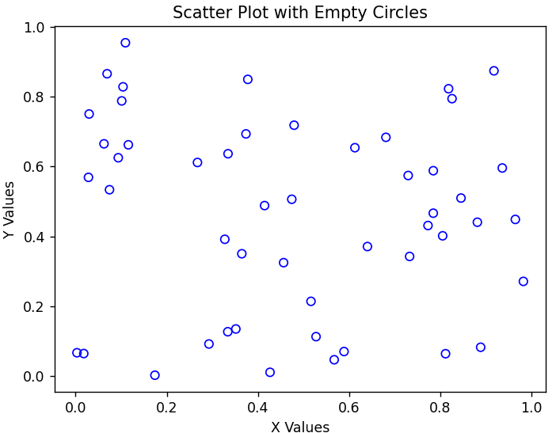
Result:
Thus, the Python program to draw a scatter plot with empty circles using random X and Y values was successfully executed.
34.Write a Python program to draw a scatter plot using random distributions to generate balls of different sizes.
Aim:
To write a Python program to draw a scatter plot using random distributions to generate balls of different sizes.
Program:
import matplotlib.pyplot as plt
import numpy as np
x = np.random.rand(50)
y = np.random.rand(50)
sizes = np.random.rand(50) * 1000
plt.scatter(x, y, s=sizes, alpha=0.5)
plt.xlabel('X Values')
plt.ylabel('Y Values')
plt.title('Scatter Plot with Balls of Different Sizes')
plt.show()
Output:
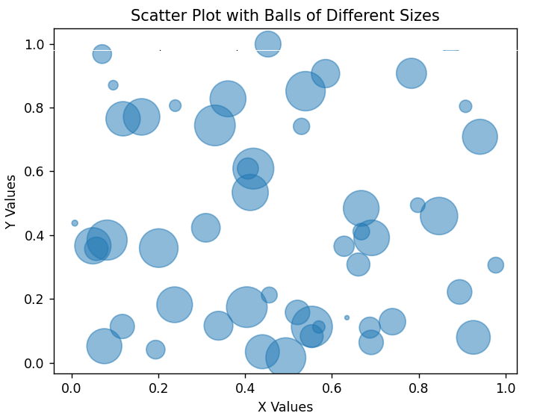
Result:
Thus, the Python program to draw a scatter plot using random distributions to generate balls of different sizes was successfully executed.

